9. Assumes the wealth of the player is w and the ticket price is c. The player would only want to play if the expected exponential rate of growth g(w,c) is positive:

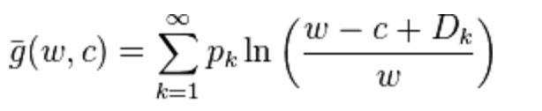

where D_k = 2^k is the payoff at round k and p_k = 1/(2^k) is the probability.

g(w,c) is a decreasing function of c. The constaint g(w,c) >0 gives the upper bound of c, which is the maximum price the player would want to pay for the game. Numerically, for w=100, c ~= 3; for w = 1million, c~=8; for w=100million, c~=12.